DATE: | Thursday, Feb. 27, 2020
TIME: | 12:00 – 1:30 pm
LOCATION: | Rubenstein 249
LIBRARY COUNCIL MEETING MINUTES

UNIVERSITY | Deborah Jakubs | MINUTE TAKER: | Katryna Robinson
LIBRARIAN:
CHAIR: | Patrick Charbonneau

AGENDA
- Welcome and Introductions

- Reprise of Academic Council Update on Libraries – Deborah Jakubs

- Lilly Library Renovation Expansion and Update

MINUTES

Welcome and Introductions
TIME ALLOCATED | 5 minutes
DISCUSSION | After lunch, Patrick and Deborah welcomed everyone to the first meeting of the semester (Spring 2020).

Reprise of Academic Council Update on Libraries
TIME ALLOCATED | 50 minutes
DISCUSSION | Deborah spoke to the Library Council about a presentation she made to the Academic Council on January 16, 2020. This serves as a great overview for Library Council as well.  Deborah started by giving Academic Council an overview of the Libraries at Duke:  Under the Duke University Libraries umbrella fall:  - Perkins & Bostock  - Rubenstein  - Lilly  - Music  - Pearse Memorial Library at the Duke Marine Lab  - Library Service Center  - Duke Kunshan  Under the Professional School Libraries fall:  - Ford (Fuqua)  - Goodson (Law)  - Divinity  - Medical Center  Deborah then showed the AC numbers at a glance for FY 19 for DUL:  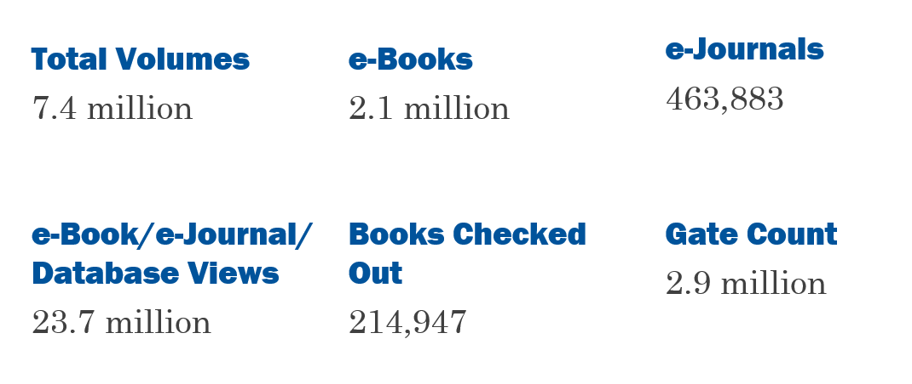  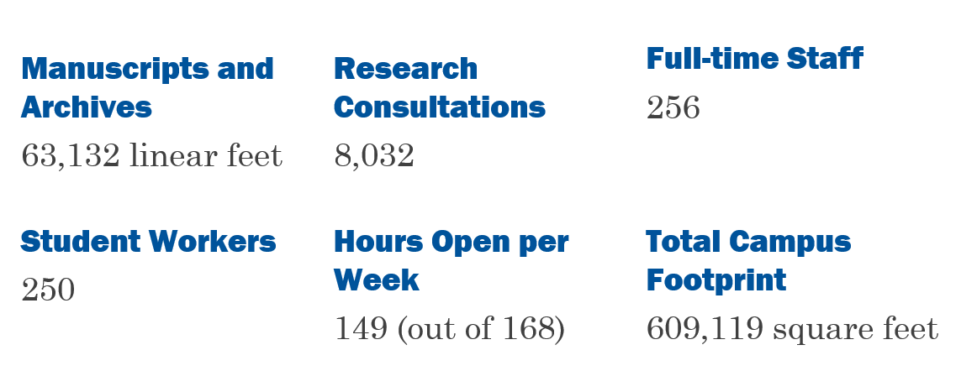  Deborah went through a timeline of DUL Capital Projects:  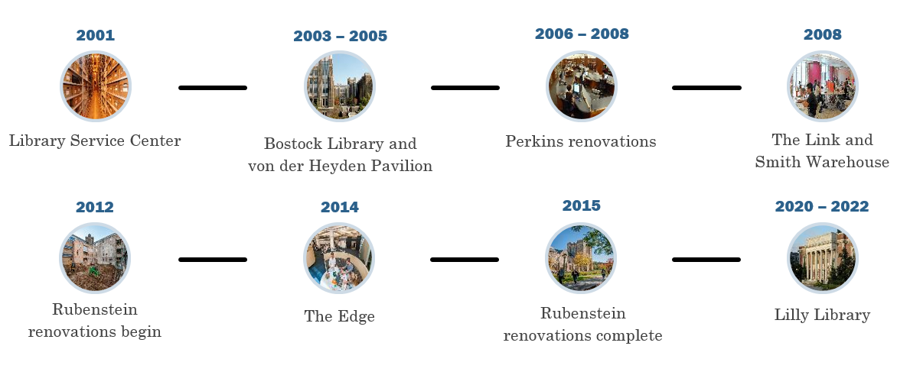  Since the renovations, the number of visitors has steadily increased, with no signs of slowing down:  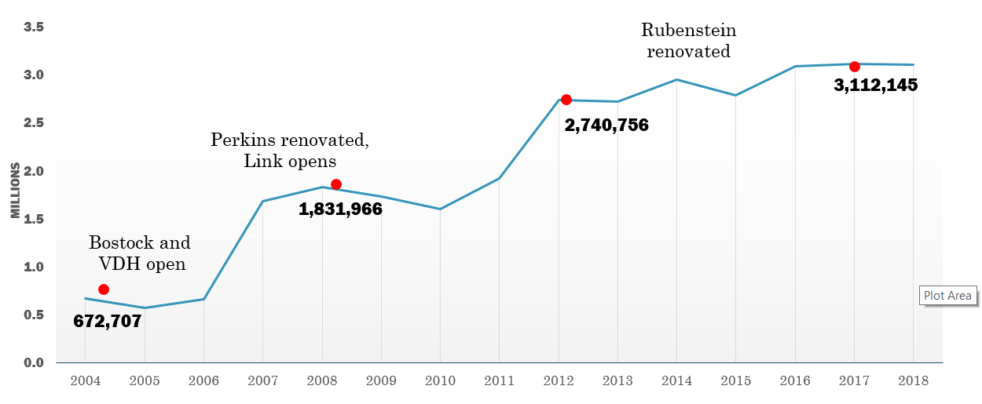  What else do the Libraries do?  - Data management and compliance  - Copyright and IP consulting  - Duke Learning Innovation  - Scholars@Duke back-end support  - Online journal hosting  - Digital Humanities project incubation  - Multimedia Project Studios  - Duke Collaboratory for Classics Computing (DC3)  - Faculty- and student-curated exhibits  - Residence hall librarians for first-year students  - Assessment and User Experience  - Dedicated space for doctoral research  - Project rooms for collaborative research  - Alumni portal for database access  - Responsible Conduct of Research (RCR) sessions  - And much more!  RCR (Responsible Conduct of Research) Forums  Beyond the RCR orientations, all graduate students have to complete additional RCR forums. These are more specialized, smaller and interactive opportunities for you to engage with faculty, librarians, staff and other professionals to explore ethical issues and concerns in your scholarship. The libraries teach many RCR forums, like:  - Acquiring and Preparing a Corpus of Texts  - Building Blocks for Reproducibility: Concepts and Practices  - Data Management 101 for Humanists  - Data Management 101 for Social Scientists  - Preparing Data for Publishing  - Digital Publishing: Multimodal Storytelling  - Digital Publishing: Reaching and Engaging Audiences  - Ethics and Visualization  - Finding a Home for Your Data: An Introduction to Archives & Repositories  - Image Copyright and Acquisition for Scholars  - Open Science: General Principles and Practices  - Research Impact Concepts and Tools  - Retractions in Science and Social Science Literature  - Shaping Your Professional Identity Online  - Evaluating Publishers, Negotiating Contracts, and Navigating the Scholarly Publishing Ecosystem  - Topic Modeling and Document Classification with MALLET  - The Efficient Archival Researcher  Some projects the Libraries have been undertaking are:  The Libraries recently created Scholarworks, a center for Scholarly Publishing at Duke University Libraries. The ScholarWorks center in Duke Libraries can help members of the Duke community increase the reach and impact of their research - by helping to develop digital projects and publications, share work broadly online, understand copyright issues, negotiate publication contracts, build reader engagement, and much more.  Project Vox seeks to highlight philosophical works from marginalized individuals traditionally excluded from the philosophical canon.  DukeSpace is Duke University's online repository for publications and other archival materials in digital format. Dissertations and theses by Duke students since 2007 are made openly available to all here, as are many publications by Duke faculty.  The Research Data Repository accepts data, documentation, software, and other code related to the teaching and research mission of Duke University, including data linked to a publication, research project, and/or class projects. Data deposit is open to all members of the Duke Community with a valid netid. All data are openly accessible for direct download.  DUL Digital Collections contains 140K+ digitized items from the Rubenstein Library.  The Center for Data and Visualization Sciences (DVS) partners with faculty, researchers, and students through consultation, instruction, co-curricular programming, and research assistance at various stages of the research data lifecycle.  DVS has had 1287 consultations to date with faculty, students and staff spanning 922 hours total.  1,287 total consultations  922 total hours  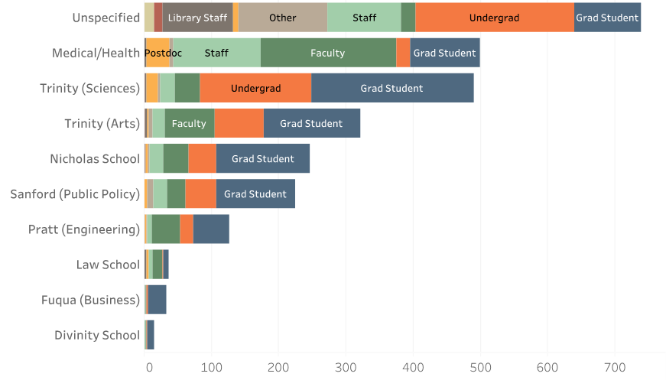  The David M. Rubenstein Rare Book & Manuscript Library is comprised of:  - Archive of Documentary Arts  - Economists’ Papers Archive  - History of Medicine Collections  - Human Rights Archive  - Franklin Research Center for African & African American History & Culture  - Hartman Center for Sales, Advertising, & Marketing History  - Bingham Center for Women’s History & Culture  - University Archives  From 2021-2017, they have served 2404 total students in various disciplines.  To date, Rubenstein Library has faced an 83% increase in instruction since 2015.  Deborah briefly discussed the Libraries’ budget and allocation. These are the major expense allocations:  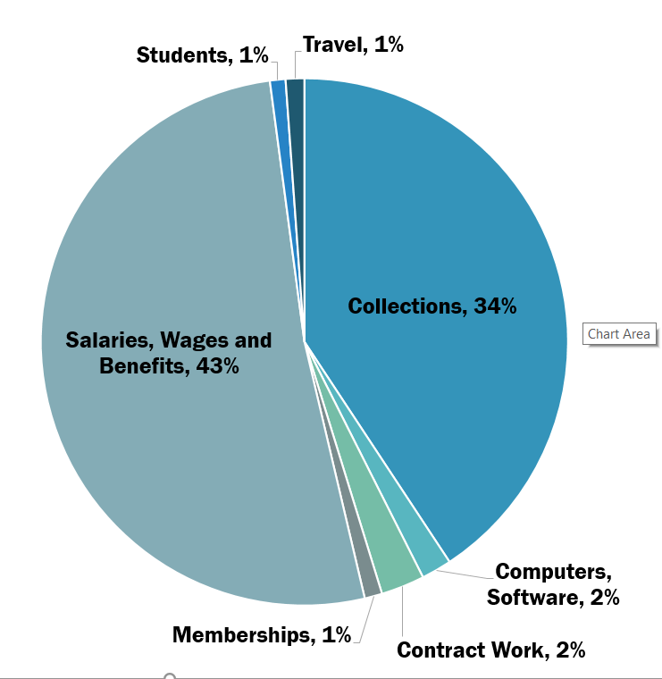  Along with the Libraries’ main funding sources:  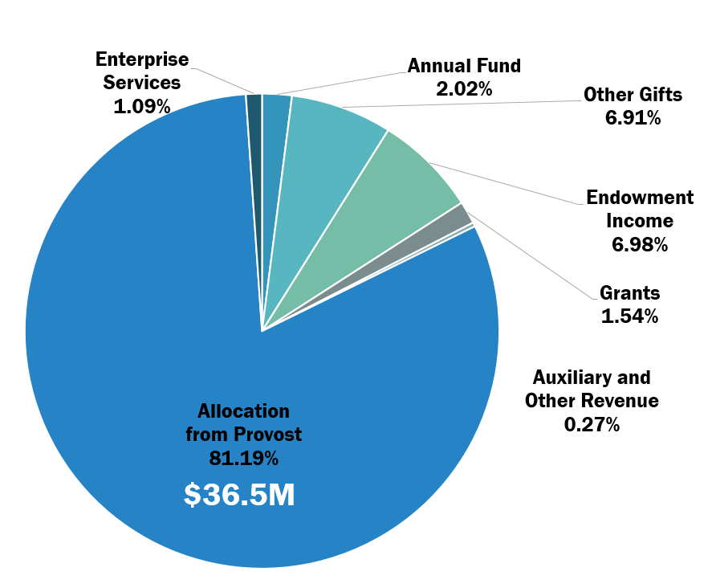  Deborah then spoke about the collections budget. DUL’s collections budget is close to $16 million. DUL has received modest increases over the years to accommodate price inflation.  Journals and licensed digital resources account for around 65%. This includes around 1,200 – 1,500 licenses. Collection endowments help, but many are restricted.  How Duke ranks amongst Ivies Plus Schools:  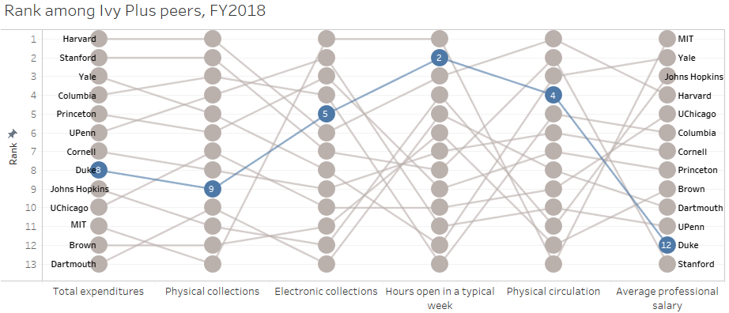  These numbers are not up to date as of FY 2022, but Duke is still last in average professional salaries (Stanford did not provide salary data).  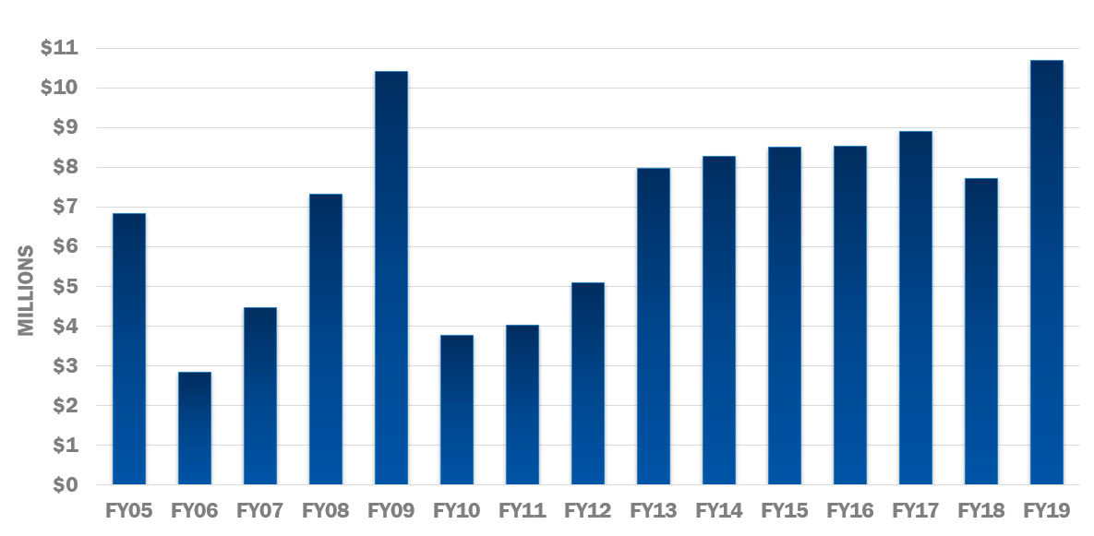  This chart depicts total cash gifts throughout the years.  Some of the challenges the Libraries face:  - Growth in Master’s Programs:  - 1,269 additional masters students over last decade (31% increase)  - Growth in master’s enrollment across almost all schools  - This has a downstream impact on Libraries. There is only 1 Librarian for Pratt, for example.  - Keeping Up with Duke’s Science and Technology Initiative  There is additional pressure on collections and staff. There are only 4 librarians for the sciences, and scientific journals tend to cost more.  - Lilly Library Renovation – the cost will add up to $47 million dollars, and the Libraries are being asked to raise the majority of that amount.  - LSC Module 4 – the cost is estimated around $17 million, compared to the cost of Module 3 in 2012 at 6 million. UNC will split the cost 50/50.  - The Libraries are anticipating the next recession.

Lilly Library Renovation Expansion and Update
TIME ALLOCATED | 5 minutes
DISCUSSION | The architects of DSK are hard at work revising the design for the Lilly Library renovation to make it more affordable while still giving East Campus what it needs. More information can be found here: https://library.duke.edu/support/lilly-library-expansion-renovation. Lilly will be discussed further at future Library Council meetings.

