DATE: | Monday, Sept. 14, 2020
TIME: | 3:00 – 4:15 pm
LOCATION: | Virtual (zoom meeting)
LIBRARY COUNCIL MEETING MINUTES

UNIVERSITY | Deborah Jakubs | MINUTE TAKER: | Katryna Robinson
LIBRARIAN:
CHAIR: | Patrick Charbonneau

AGENDA
- Welcome and Introductions (Patrick Charbonneau, chair, Deborah Jakubs)
- Report on the reopening of library spaces (Dave Hansen, Naomi Nelson, Tim McGeary)
- Budget update (Ann Elsner)
- Feedback from Council on library services (all)
- Brainstorming on 2020-21 Council agenda (all)

MINUTES

Introduction
TIME ALLOCATED | 5 minutes
DISCUSSION | Patrick and EG welcomed everyone back to Library Council after a long hiatus due to COVID.

Report on the reopening of library spaces
TIME ALLOCATED | 45 minutes
DISCUSSION | Dave, Naomi and Tim gave an overview of the reopening of library spaces after COVID forced a shutdown in March of 2020.  Dave started by giving everyone a timeline of what happened since then:  - March 18: Library closed to users  - March 20: Almost all library staff begin working from home  - All onsite services suspended. Virtual services bolstered (chat, email, virtual consultations and instruction), HathiTust ETAS access added in following weeks  - Mid June - some staff return onsite for scanning, reshelving large numbers of returned materials, general clean up  - June 29 - Library Takeout Service starts (all buildings remain closed to non DUL staff)  - August 17:  - Library takeout locations shifted and expanded to undergraduates  - SEATS reservations online  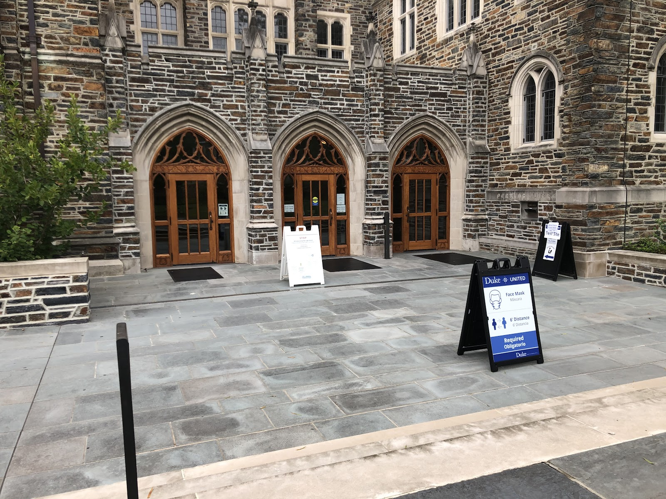  For the first time in a long time, the doors to the building were closed to the public and to students, faculty and staff. In Fall of 2020, the doors became swipe only access to the Duke population.  DUL reopened on August 17. The RL Reading Room reopened September 14.  Open study and services are available by location:  - West Campus: Mon – Fri: 8:30 am – 11 pm  - East Campus/Lilly: Mon – Fri: 2 – 11 pm  - East Campus/Music: Mon – Fri: 10 am – 3 pm  - The Perk: Reopened August 17; closed September 4 due to lack of business  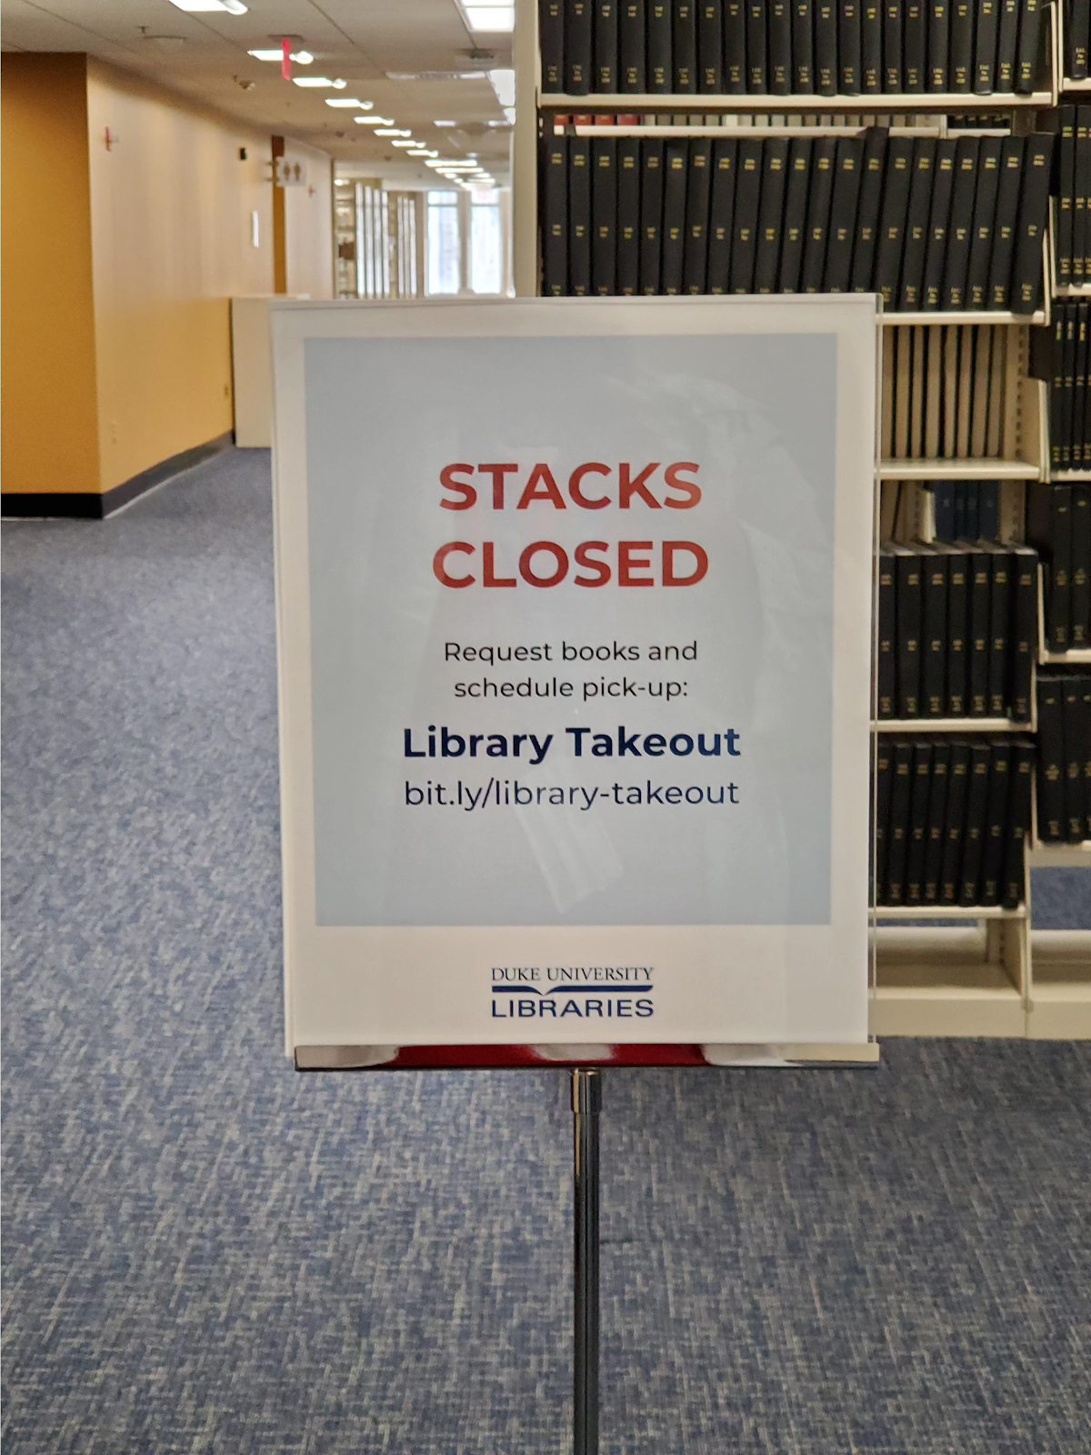  This is not a sign no one expected to see in Perkins & Bostock, but while it’s caused a lot of new work, closing the stacks has been essential to promoting the safety of our staff and our patrons. We all appreciate the support we’ve gotten to help make this happen.    A library employee, Jamie Keesecker, used his free time during the pandemic to create an awesome music video explaining to patrons how to check out a book:  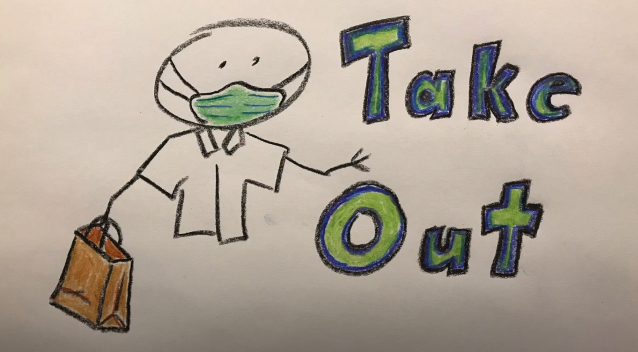  https://www.youtube.com/watch?v=e1iGEM9NMFM  Tim’s staff in Assessment & User Experience (AUX) were able to update the website so folks could request books to be taken out, users could reserve a seat or a scanner, microform reader, video viewing station, and other equipment.  AUX made several changes to this page as they’ve observed students’ behavior over the last week and a half. For instance, they heard from security staff and students that DUL needed to provide clearer steps for making reservations and also include information about the Symptom Monitoring app, so they made that change.  They also made several seats reservable (see image below).  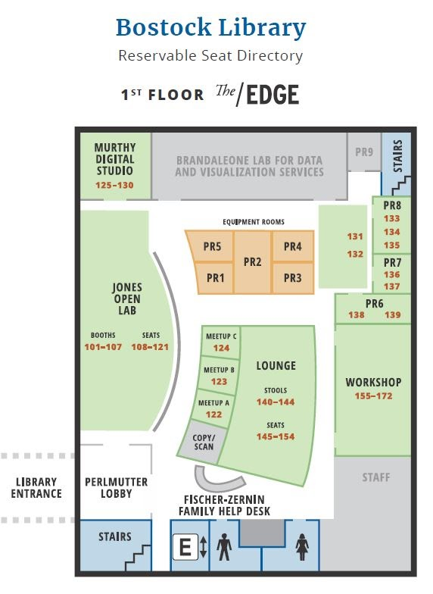  Every reservable seat in each library has a number, and they knew from the start of their work that they would need signs to help students get to their numbered seat. They developed maps like this one of The Edge to help users get to the seats or equipment they reserved. You could see the seat numbers in a picture of the Gothic Reading Room below.  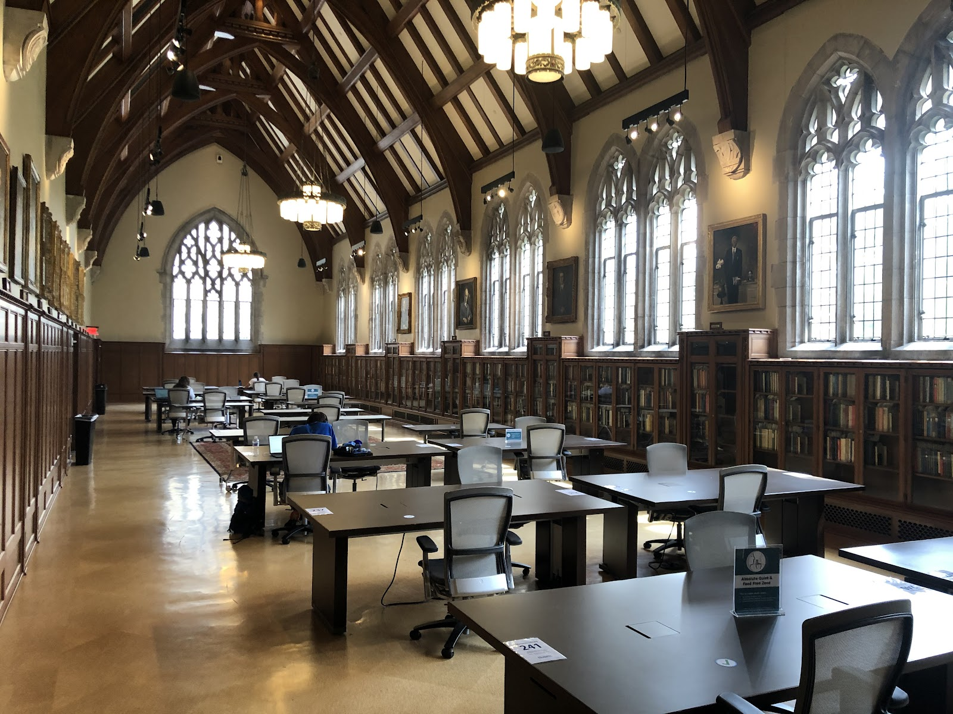  Naomi completed the presentation by talking about what Rubenstein Library has been doing. Since June, a small group of RL staff have been back on campus scanning material for classes and helping to develop and test workflows for the fall.

Budget Update
TIME ALLOCATED | 5 minutes
DISCUSSION | Ann gave a brief update about the library budget. The Libraries have been asked to cut the budget by 3.75 million over the course of 3 years. This has and will heavily impact collections, and the recruitment and retention of employees.

Brainstorming on 2020-2021
TIME ALLOCATED | 5 minutes
DISCUSSION | EG took suggestions from the Library Council on future topics for the meetings. LC members wanted to hear more about public services, computing, Lilly Library, the budget, and HR updates to name a few.

