DATE: | Tuesday, October 23, 2018
TIME: | 11:43 PM – 12:58 PM
LOCATION: | Perkins 218
DUL LIBRARY COUNCIL MEETING MINUTES

MEETING CREATED BY: | Deborah Jakubs | MINUTE TAKER: | Katryna Robinson
FACILITATOR: | Jimmy Roberts | TIME KEEPER: | Katryna Robinson
AGENDA: | - Introductions and Announcements  - The business of scholarly publishing, or “Who owns your research process?” – David Hansen  - Faculty Newsletter – Deborah Jakubs

ATTENDEES PRESENT:
Tom Witelski | Tim McGeary | Ann Elsner | Deborah Jakubs
Dracine Hodges | David Hansen | Joel Herndon | Patrick Charbonneau
Phil Stern | Lynn Smith-Lovin | Victoria Szabo | Saheel Chodavadia
James Roberts | Anthony Kelly | Henry Pickford | Phil Stern
Naomi Nelson | Brian Murray | Tom Mitchell-Olds

MINUTES
The business of scholarly publishing
or
“Who owns your research process?”
TIME ALLOCATED | 30 mins |  | PRESENTED BY | David Hansen
DISCUSSION | A recurrent theme in NC recently has been water. We survived 2 hurricanes, several floods. As we talk about what we’re doing in the libraries, we often revert to this analogy of research life cycle, Dave thought it would be helpful to look at the water life cycle.  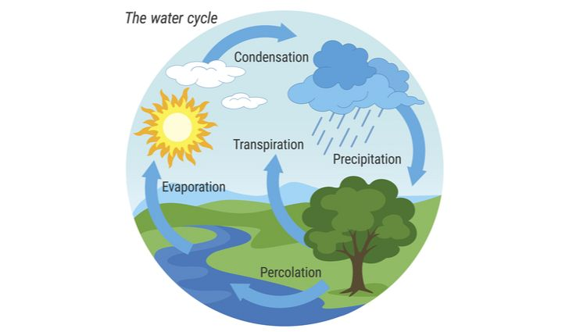  The research process  If you go into any first year research class, you’ll see a chart that help students learn about their research. How that cycle has changed and how division has been engaged and working on changes in that cycle. The water cycle, like the research cycle, is in reality much more complex.  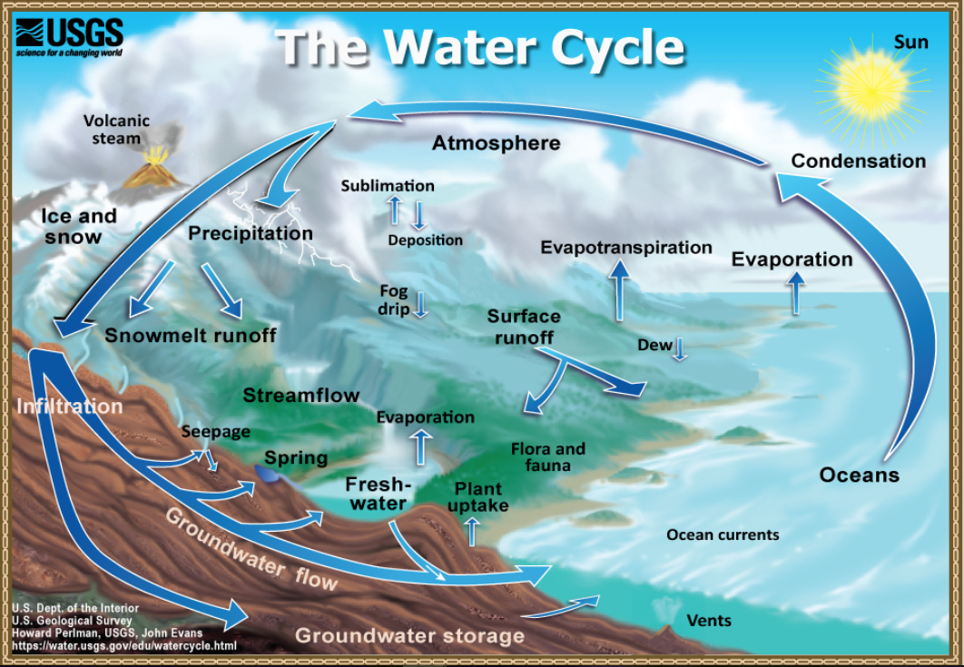  Much like the research cycle:  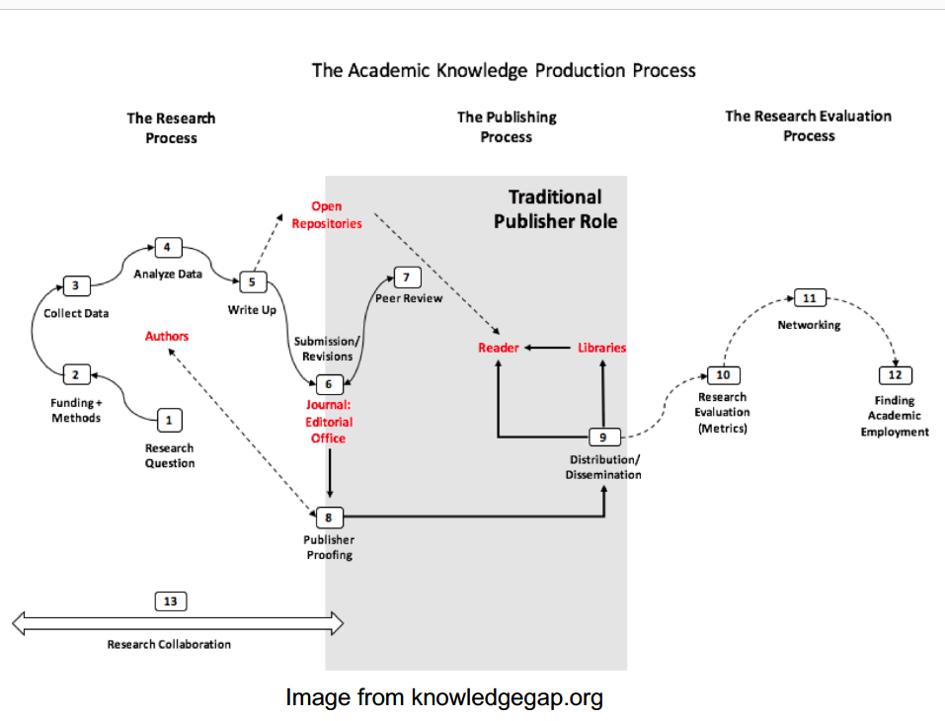  We help researchers access the system, navigate the system, and we are working on improving the system.  There is a dysfunction in publishing. Universities, gov’ts, and grant funders pay three times for research*:  - They pay authors to conduct research and draft papers, which they transfer gratis to publishers  - They pay faculty who volunteer their time to peer-review and edit journal submissions  - They pay publishers for access to the final, published articles, written and edited by our faculty  *Adapted from B. Butler & J. Unsworth, Research Information Costs at the University of Virginia, 2018  Fig 3. Percentage of papers published by the five major publishers, by discipline in the Natural and Medical Sciences, 1973–2013. 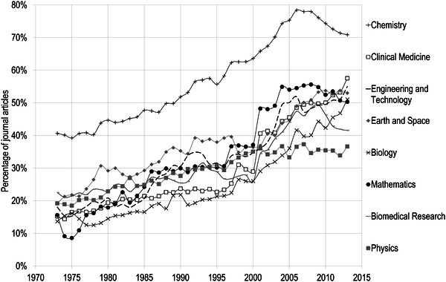  Larivière V, Haustein S, Mongeon P (2015) The Oligopoly of Academic Publishers in the Digital Era. PLOS ONE 10(6): e0127502. https://doi.org/10.1371/journal.pone.0127502  https://journals.plos.org/plosone/article?id=10.1371/journal.pone.0127502  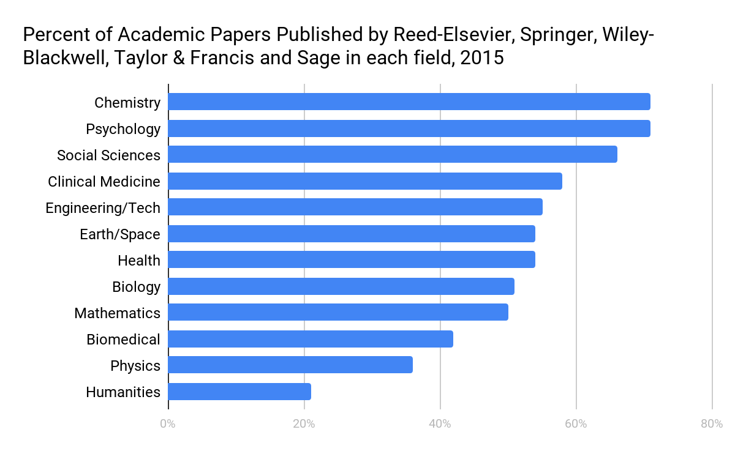  Total Elsevier revenue for 2016: $3,014,140,000  Total Elsevier operating profit for 2016: $1,108,220,000  If you calculate this out, we’re spending a TON of money on these services. In addition to library subscriptions (which are high. Duke’s annual subscription is on the order of $2million/yr for Elsevier alone), universities are giving away an incredible amount of value to these commercial vendors.  One way to look at that is in time dontated-- recent report on the state of peer review indicated that academics dontate 68.5 million hours per year to publishers. Multiply that times avg. annual rate -- close to $1billion in donated time.  Or, look at it from the output perspective -- our authors produce a big chunk of Elsevier titles:  Total Elsevier articles published in 2016: 420,000 (per Elsevier’s annual report)  Total Elsevier articles written by Duke authors in 2016: 2,853 (0. 679285714% of total 2016 Elsevier articles)  Total Elsevier articles written by UNC Chapel Hill Authors: 1,954* (0.465238095% of total 2016 Elsevier articles)  Total Elsevier articles written by NCSU authors: 1,717 (0.408809523% of total 2016 Elsevier articles)  Total Duke, UNC, NCSU authored Elsevier articles: 6,524 (1.55333% of total 2016 Elsevier articles)  Proportional share of Elsevier revenue from Duke, UNC, NCSU articles: $3,014,140,000 x 1.53333% = $46,216,713  Proportional share of Elsevier operating profit from Duke, UNC, NCSU articles: $1,108,220,000 x 1.5333% = $16,992,338  Profit Margins:  - Pharmaceuticals (Pfizer): 42%  - RELX (Elsevier): 39% on ~ $3 billion annual revenue (2016)  - Apple: 37%  - Taylor & Francis: 36%  - Springer-Nature: 35%  - Banking (Industrial & Commercial Bank of China): 29%  - Wiley: 28%  - Automotive (Hyundai): 10%  Adapted from B. Butler & J. Unsworth, Research Information Costs at the University of Virginia, 2018  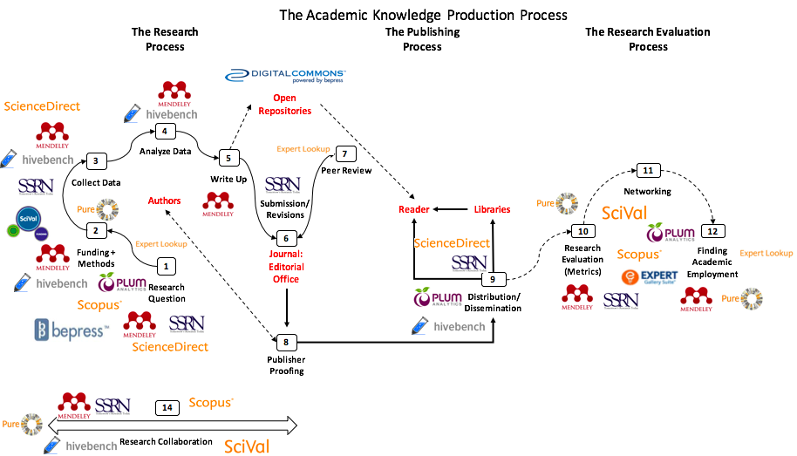  Generally Good, but problematic when all controlled by one company (Elsevier).  Some ideas:  - Open infrastructure (both nonprofit and commercial)  - Help reinvigorate alternative publishers  - Scholarly Societies  - University Presses  - Open access licensing
CONCLUSION | N/A.
ACTION |  | ACTION TO BE TAKEN BY |  |  | DATE TO BE ACTIONED BY
Elsevier will be a topic on the agenda in the Spring. |  | 5/4/2019 |  |  | 3/27/2019

Faculty Newsletter
TIME ALLOCATED | 10 mins |  | PRESENTED BY | Deborah Jakubs
DISCUSSION | Deborah presented on the Faculty Newsletter and solicited feedback from faculty members of the Library Council on how to get faculty members to sign up for the Libraries’ Faculty Newsletter.  Many faculty members are unaware of the newsletter. DUL is given the list of new faculty members coming into DUL, but we do not have access to the entire list of faculty members.  Some suggested contacting department heads and having them add the link to the faculty newsletter sign-up sheet in their department newsletters, but many faculty members stated that they do not read some of the newsletters they receive.
CONCLUSION | N/A.
ACTION |  | ACTION TO BE TAKEN BY |  |  | DATE TO BE ACTIONED BY

